Networking Exercise 001 - IP Address

- IP Address:An IP address is a unique address assigned to a device on a network. It allows devices such as computers, phones and printers to identify and communicate with each other.If a device does not have a valid IP address, it may not be able to communicate on the network.
- IPv4 Address:IPv4 is the most common version of IP addressing and consists of four numbers separated by periods, for example:
192.168.1.100
On a home network, your laptop is typically assigned a private IPv4 address by the router using DHCP.
- Default Gateway:The default gateway is usually the router on a local network. It acts as the path that allows devices on the network to communicate with devices outside the local network, including the internet.
- Public Network:
A public network is a network that is open to the public, such as those found in:
- Hotels
- Airports
- Cafés
- Libraries
Because public networks are shared by many users, they are generally considered less secure than private networks.
- Private Network:A private network is a trusted network, such as a home or business network. Devices can communicate with each other more easily and additional sharing features are often enabled.Private IP addresses are not directly accessible from the internet.
Examples:
192.168.x.x
10.x.x.x
172.16.x.x – 172.31.x.x
- LAN (Local Area Network):A LAN is a network that covers a small geographic area, such as:
- Home network
- Office network
- School network
Devices on the LAN can communicate directly with one another.

- WAN (Wide Area Network):A WAN is a network that covers a much larger geographic area and connects multiple LANs together.
Examples:
- A company with offices across the UK
- The internet

Objective:
Check whether my laptop has successfully joined my home network.
Command Used: using command prompt cmd
ipconfig
What I observed:
- My laptop has an IPv4 address.
- My laptop has a Default Gateway.
What I learned:
- An IP address is my laptop's address on the network.
- The router usually gives my laptop an IP address.
- The Default Gateway is usually my router.
Skills demonstrated:
- Networking fundamentals
- Command Prompt usage
- Basic troubleshooting

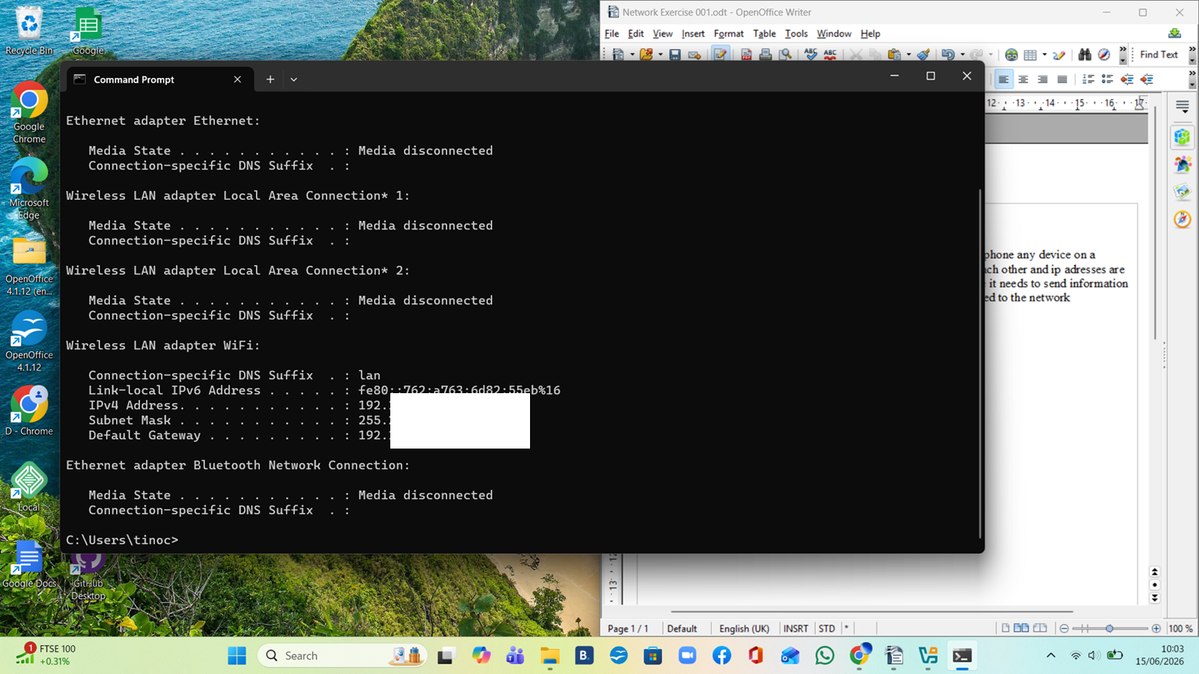


Invistgation and testing
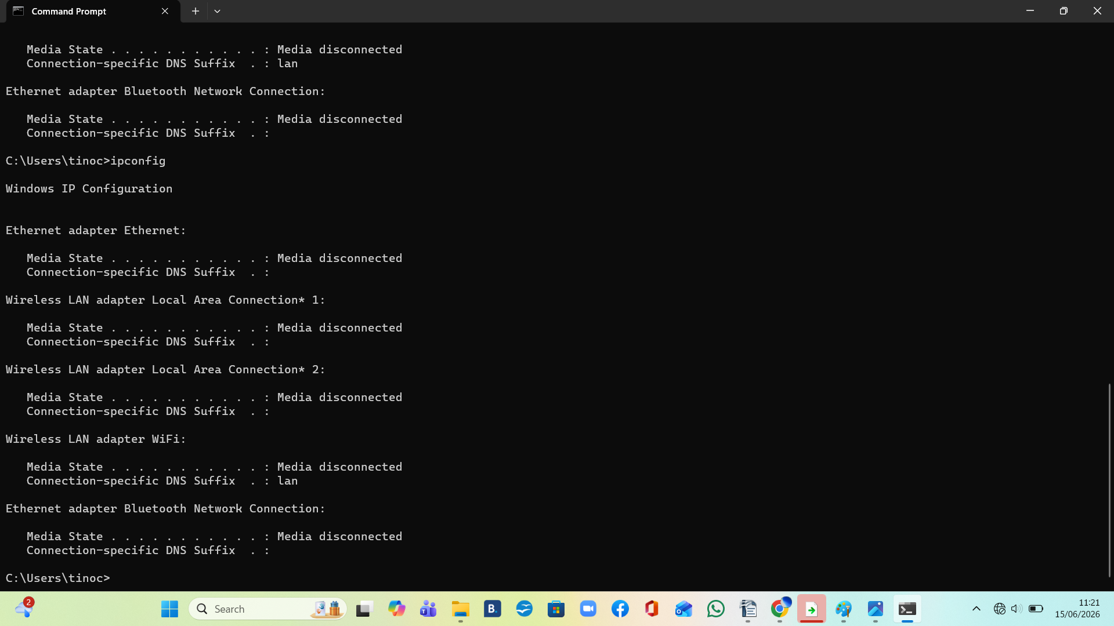
when you turn wifi off you cannnot see the ip adress

